# General description

Badf is a tool for transforming FPLs in REC datas of Topsky-ATC system into SKPs in the EXE file of Topsky-Training system, based on user input simulation time and simulation sectors. The EXE file can be run in Topsky-Training system. The purpose is to reproduce the air situation related to the simulation sector area at the simulation time in the Topsky-Training system.



In order to facilitate users to edit EXE file of Topsky-Training system at home or at work, the tool is developed using java which can be run both in windows and linux.

The main functions of the tool are as follows:

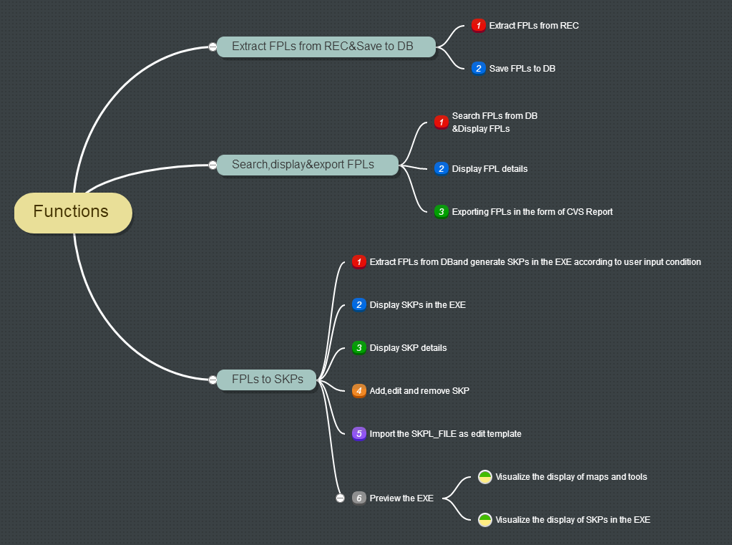

# Function description and design consideration

1. Extract FPLs from REC&Save to DB
2. The tool extract FPLs from REC datas. Rec datas are the datas from local recording folder in REC node, REC data file pattern like this:



The status of all these FPLs are “canceled”. That means the FPL information contains the real flight process.

1. Then the tool save these FPLs to DB.

**Design consideration:** DB using microft access database. Because this database does not need to be installed, and is convenient for exporting data to CVS report format at any time. In addition,the database supports windows and linux without configuration.

**Screenshots:**

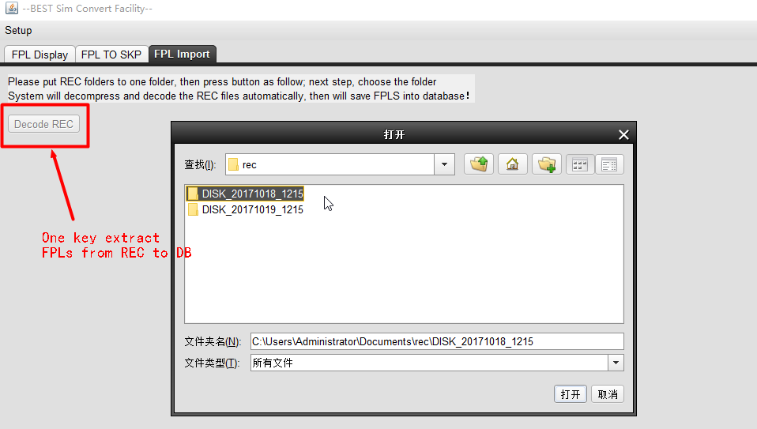

1. Search,display& export FPLs
2. Search FPLs from DB&Display FPLs

The tool allows user to display all or eligible FPL list by entering query conditions from DB.

**Screenshots:**

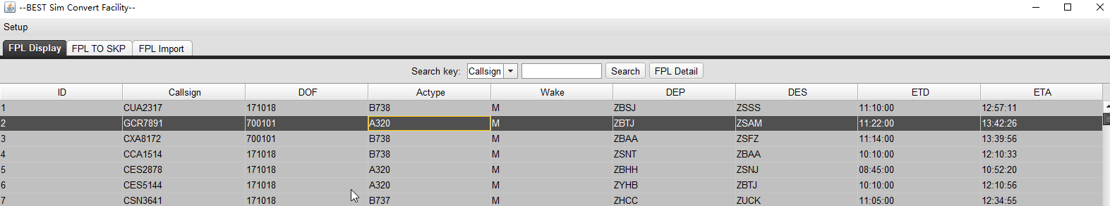

1. Display FPL details

The tool allows user to display the FPL details by select a FPL row in FPL list.

**Screenshots:**

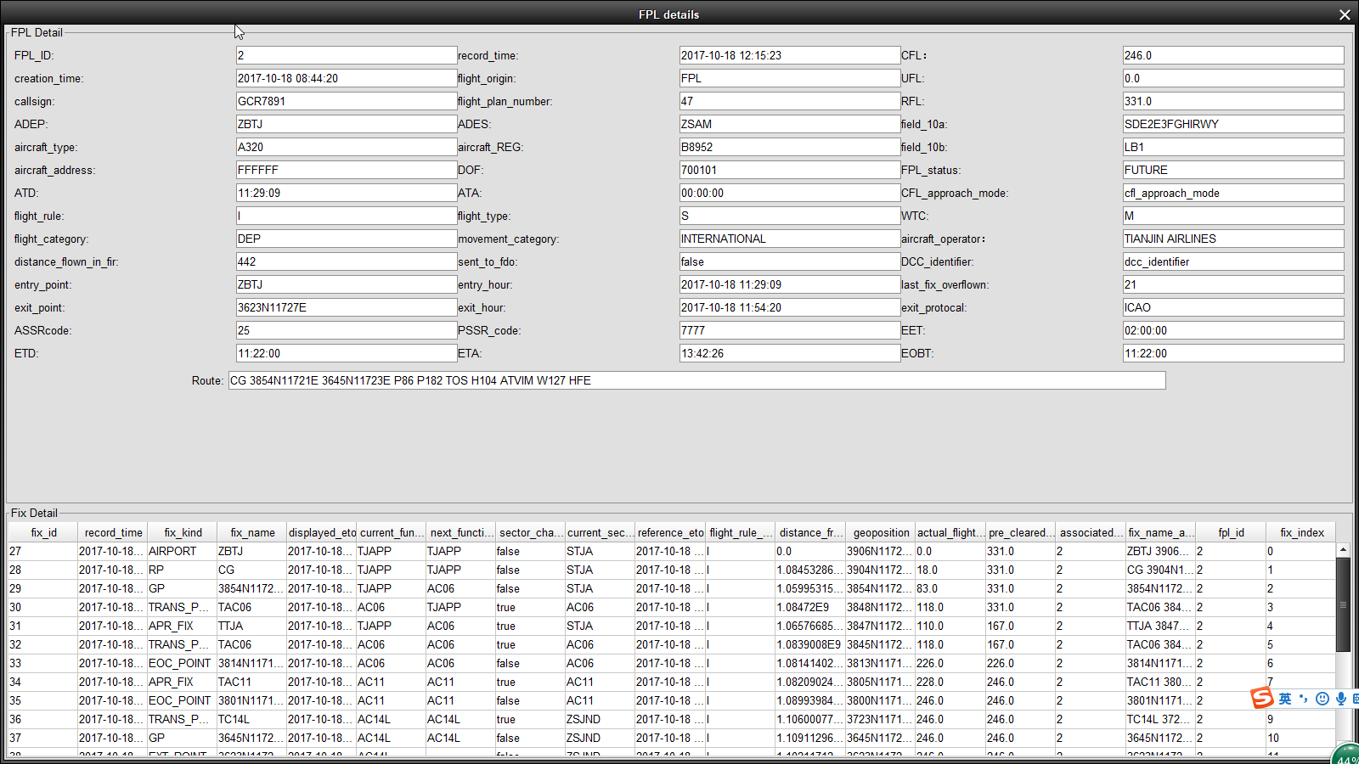

1. Exporting FPLs in the form of CVS Report

The tool allows user to export the FPL list in the form of CVS Report.

1. FPLs to SKPs
2. Extract FPLs from DB and generate SKPs in the EXE file according to user input condition

The tool can extract FPLs from DB and generate SKPs. The Generated SKPs will be put in the EXE file which be selected by user.



**Deasign consideration:** The FPL from DB contains the information how a flight fly passed every route-point, such as current_functional_sector, geoposition, reference_eto, actual_flight_level, etc.

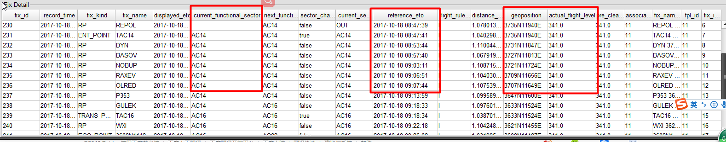

User input simulation time and sectors.



If the flight passes through these inputed sectors, the FPL will be included in the comparation as follow.

Then tool is compared with the reference_eto in every route-point according to simulatation time. The result of comparison is used to generate a SKP with AAT, route, FL. There are two possibilities in the result of one FPL as follows: (rp1, rp2, rp3…rpn are the route-points in th FPL)

Case 1: Simulate Time < reference_eto of rp1



Case 2: reference_eto of rp1< Simulate Time < reference_eto of rpn, so the apperance point in route of new SKP will be a latlon point between some rp and the next rp by computing.Its name will be added to the /B suffix, indicates it is apperance point.



Case 3: Simulate Time > reference_eto of rpn



1. Display SKPs in the EXE

The tool can refresh and display the SKP list in the EXE file, the EXE file no. is input by user.

**Screenshots:**

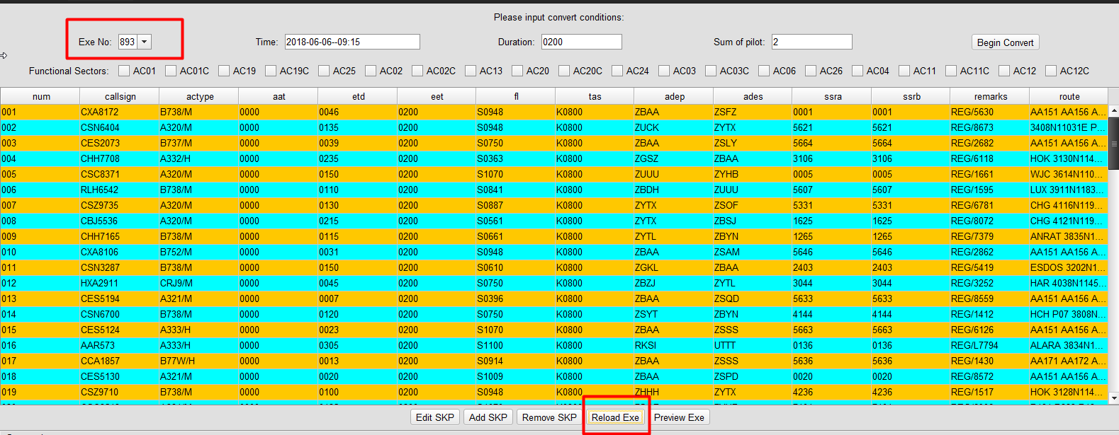

1. Display SKP details

The tool allows user to display the SKP details by select a SKP row in SKP list.

**Screenshots:**

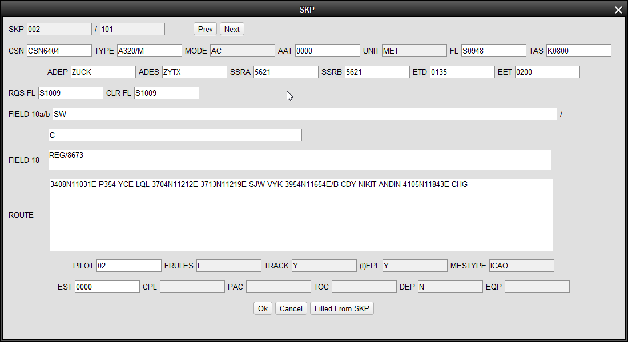

1. Add,edit and remove SKP

The tool allows user to add,edit and remove the SKP in the EXE file.

**Screenshots:**

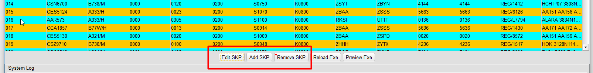

1. Import the SKPL_FILE as edit template

The tool allows user to import the SKPL_FILE as edit template when a SKP being edited. The contents of the text boxes in the edit window can be filled from the SKP_FILE file.

**Screenshots:**

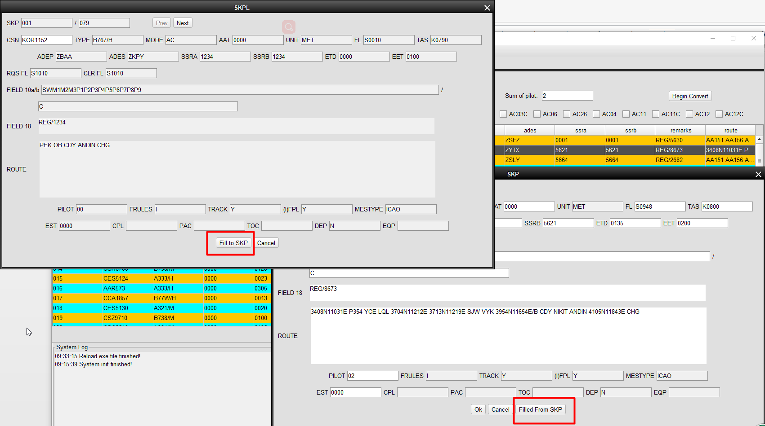

1. Preview the EXE

The tool allows user to preview the SKPs in the EXE file to cheak if the route-points in SKP is right. The tool provides a graphical window to overlay display maps and SKPs.

1. Visualize the display of maps and tools

The tool can display system maps, compass, range rings, distance measuring line and so on. The color can be changed by user.

**Screenshots:**

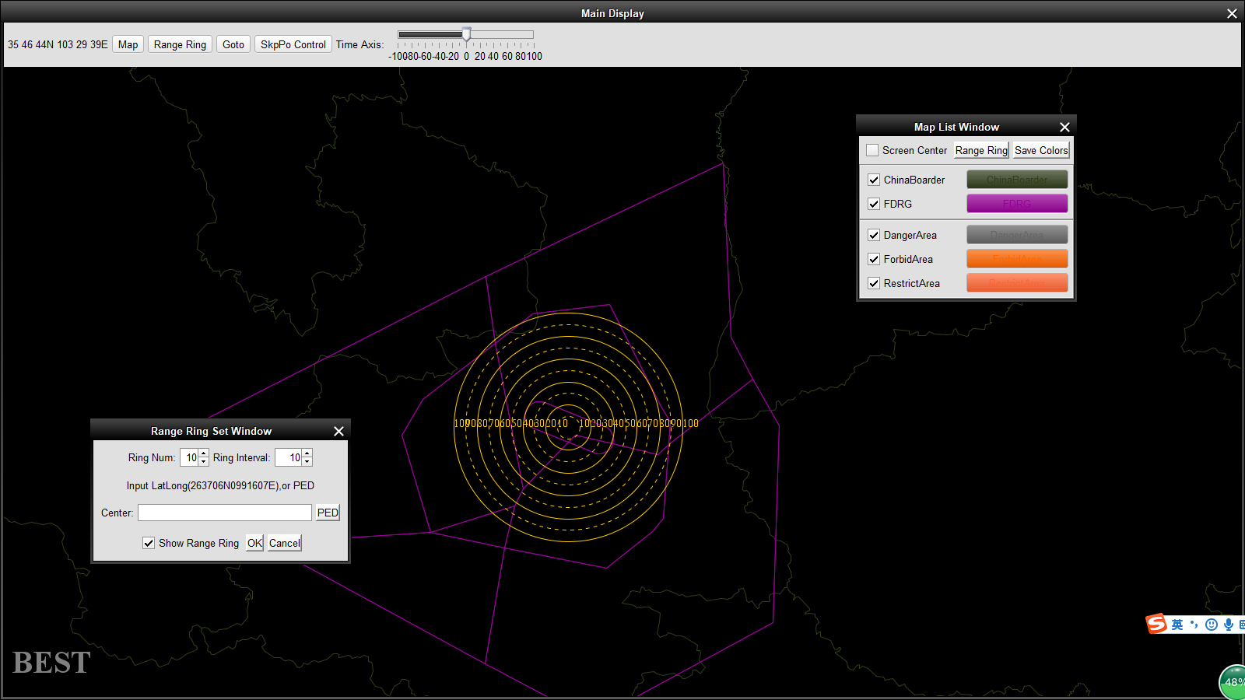

1. Visualize the display of SKPs in the EXE

The tool can display some or all of the SKPs in the EXE according user input. Each SKP consists of a label and a series of route-points. The color of a label depends on the AAT of the SKP. If AAT of the SKP==0, means the SKP is active, the color of its label is green. The position of the label is at the point of appearance. The route points that have not yet been passed are green, indicating that the route points already used are white. If AAT of the SKP>0, means the SKP is not active, it will be active in the future, the color of its label and its route-points is blue. Clicking the label with the right mouse button will popup the SKP details window to display the details of the SKP.

**Screenshots:**

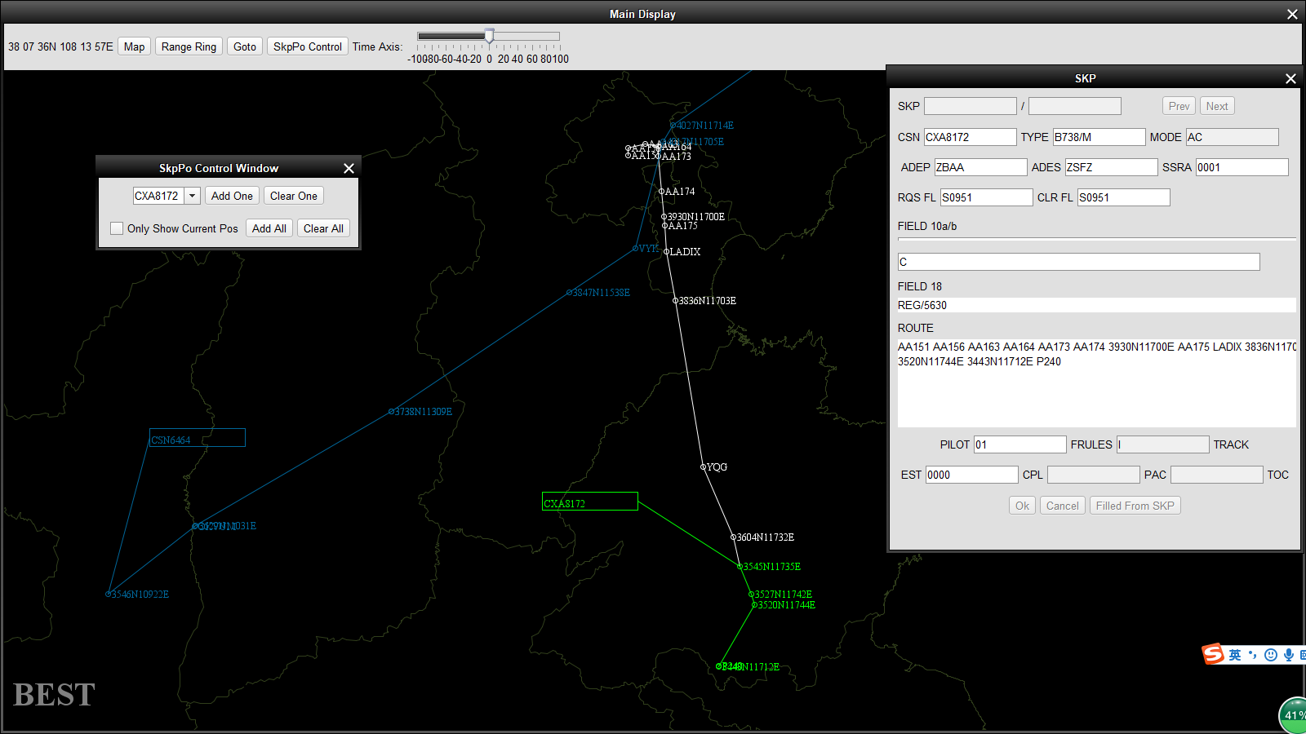

# Installation and deployment

The tool does not need to be installed. It comes with JDK. It only needs to execute files in directory to run bdaf.bat in windows or bdaf.sh in linux. The structure of the tool folder is as follow:

